**Topic -1: Pod presets in Kubernetes**

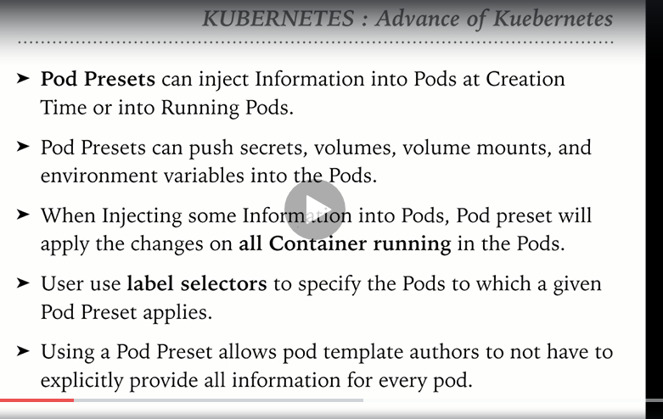

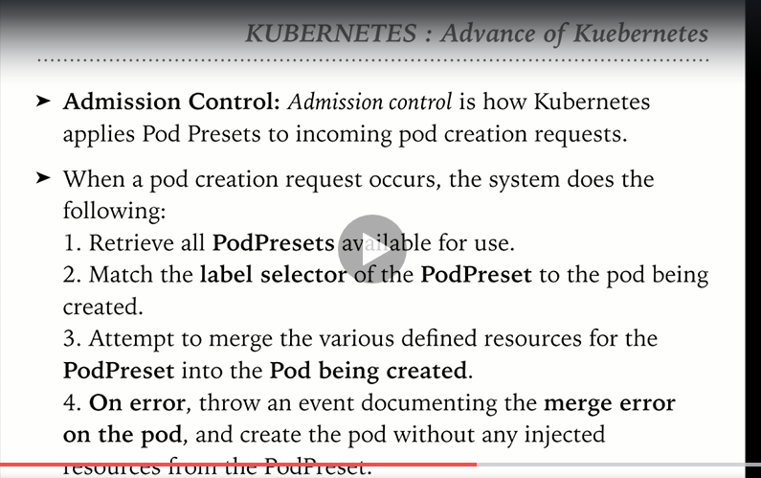

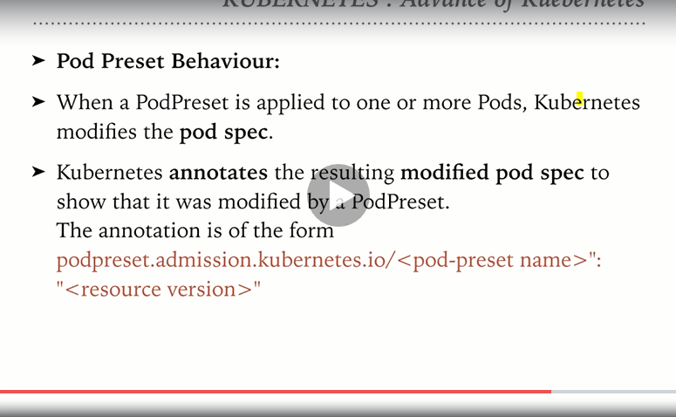

By default Pod preset is disabled in the Kubernetes

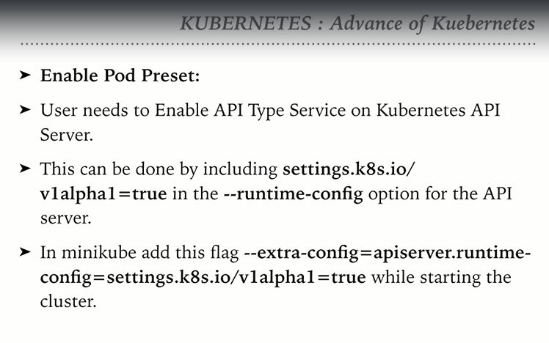

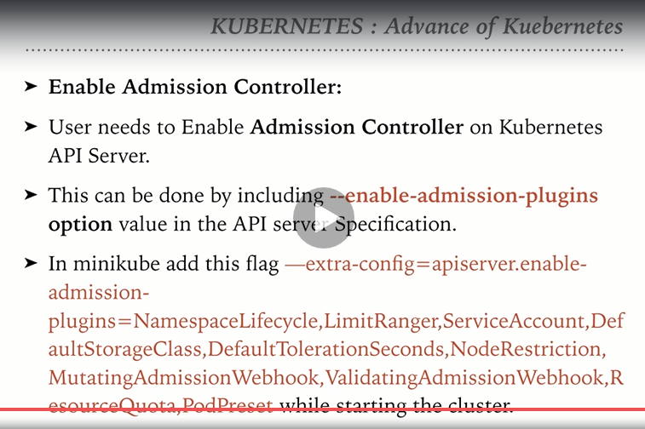

Pod presets: Hands on

Stop the minikube service

Start the Kubernets cluster on AWS:

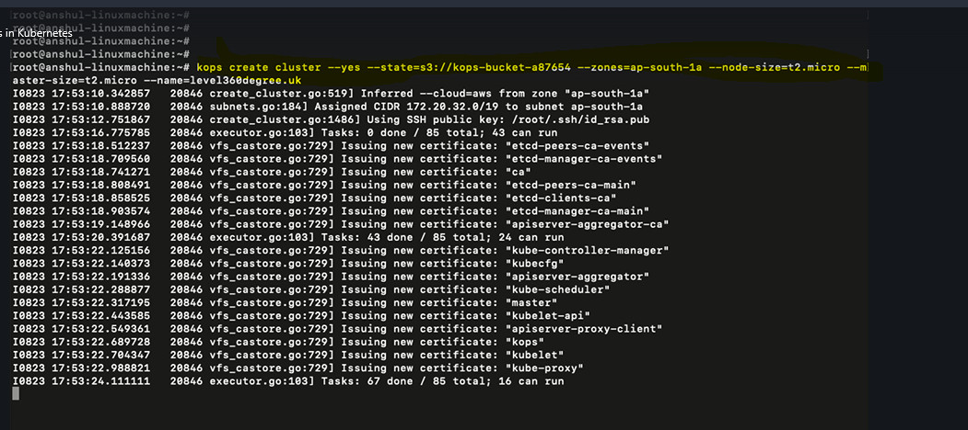

Check the status of the cluster:

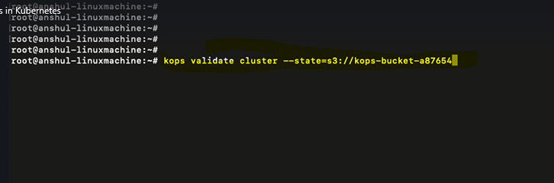

Get the cluster name

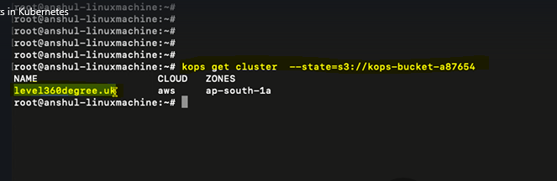

Edit the cluster

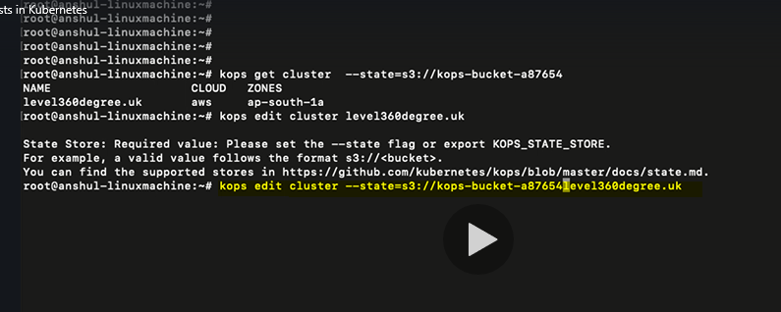

We will enter to the edit mode of the cluster

Search for an entry named “KubeAPIServer” by typing : and search for <KubeAPIServer>

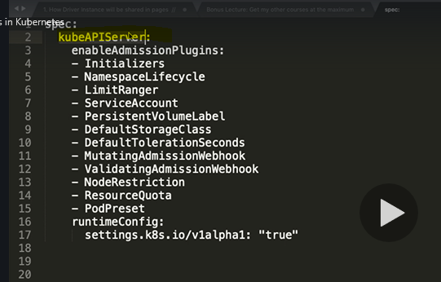

**If you do not find the search text then press I to go to insert mode and copy the contents below the Topology tag:**

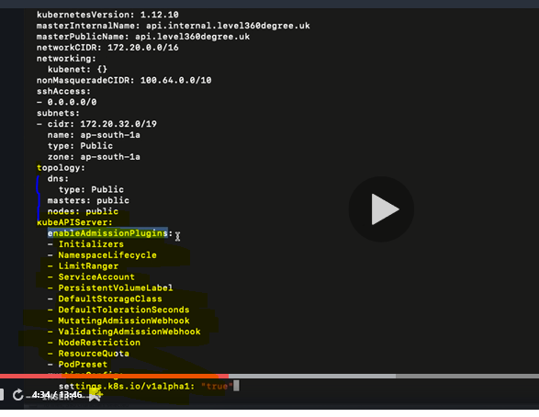

**After editing the cluster update the cluster using the below command**

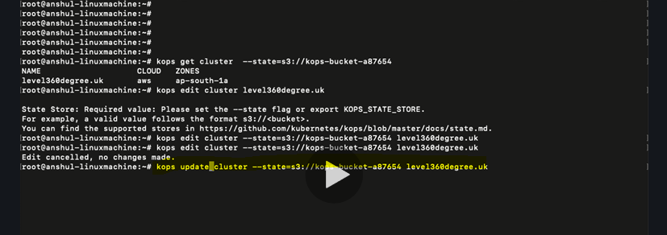

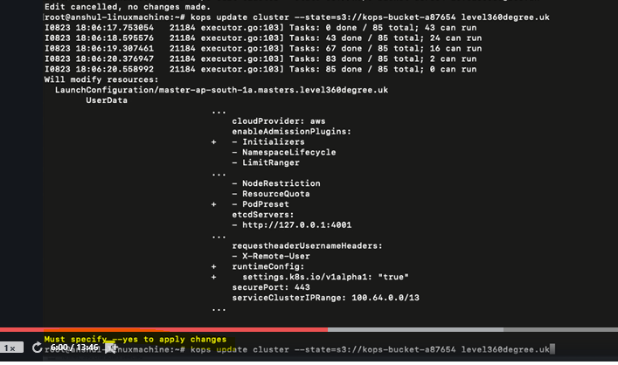

**Confirm:**

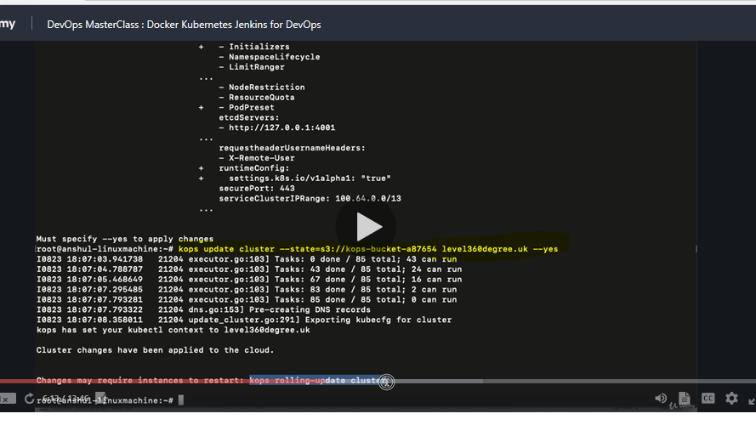

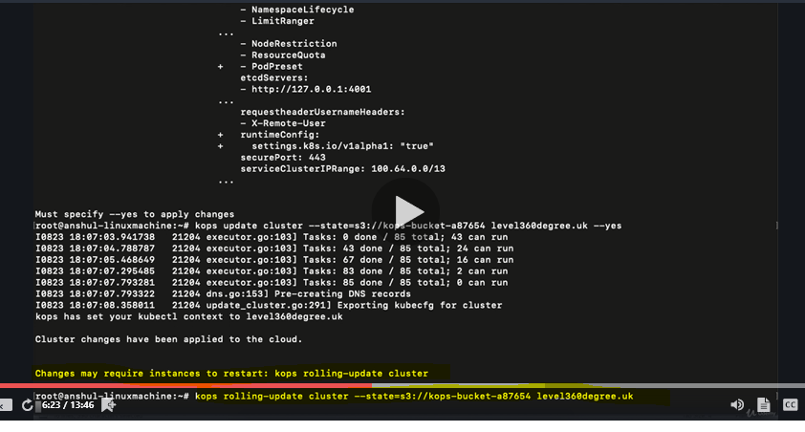

**Observe in AWS console that the old instances are getting terminated and new instances with the updates are spinning up**

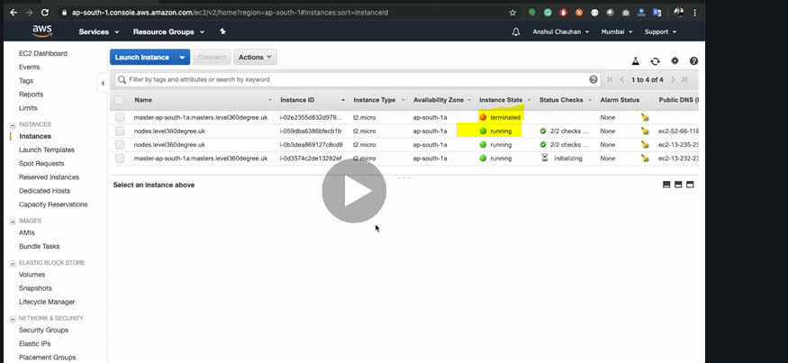

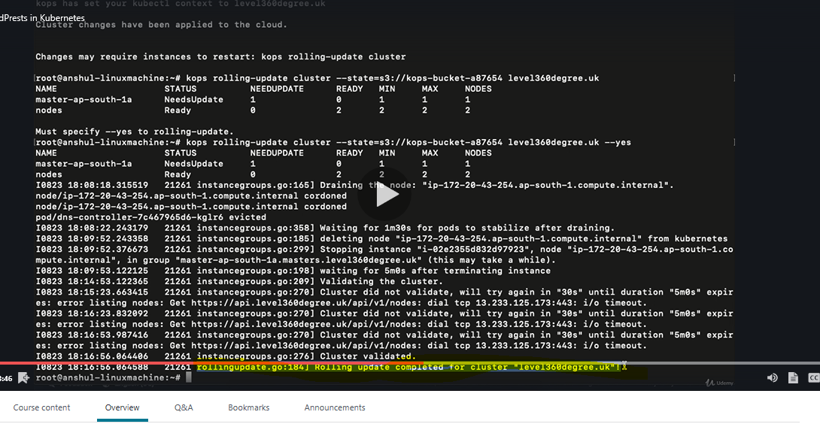

**Create a yml file**

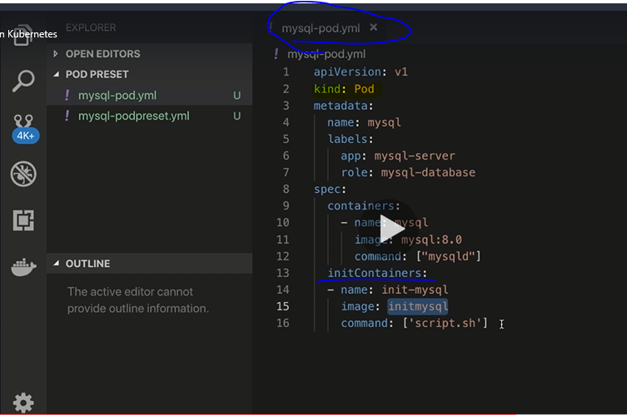

**Also create a pod preset:**

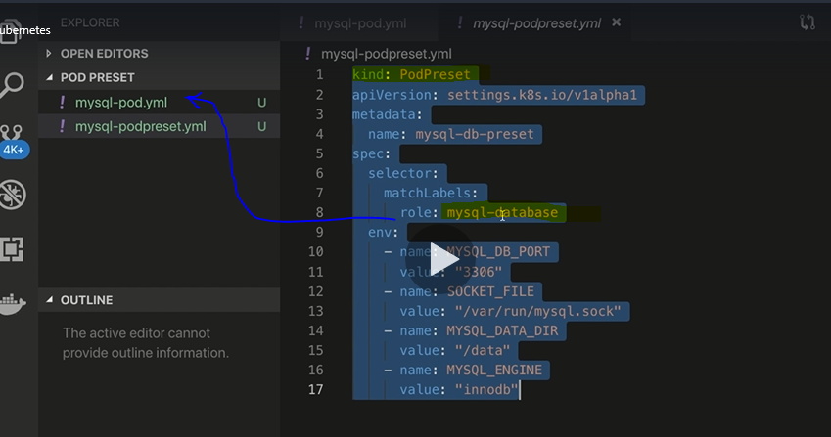

**Create a prodpreset**

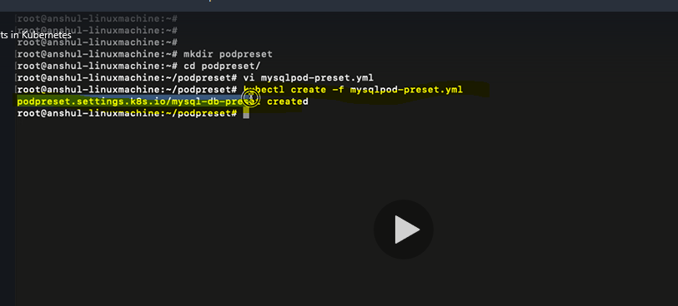

Describe podpreset

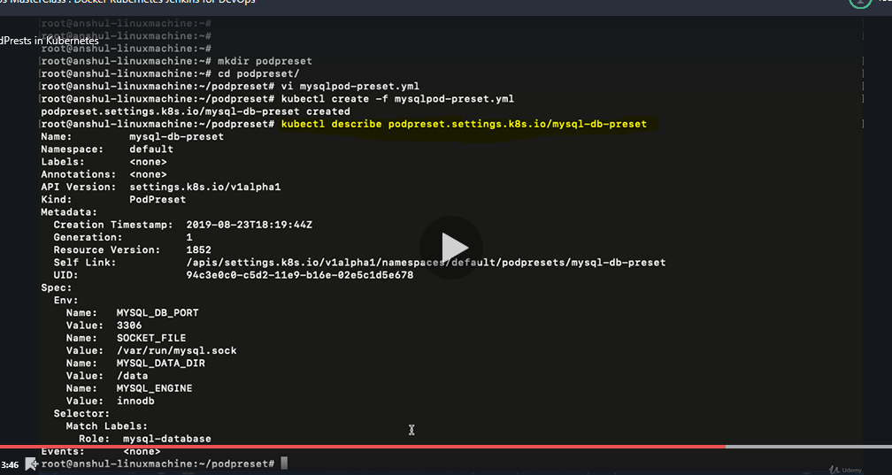

**Create DB pod:**

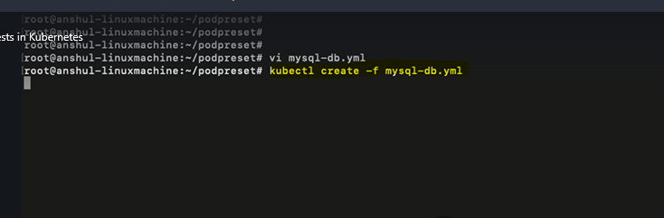

**Describe the mysql db pod. Observe that the presets mentioned earlier are part of the pod**

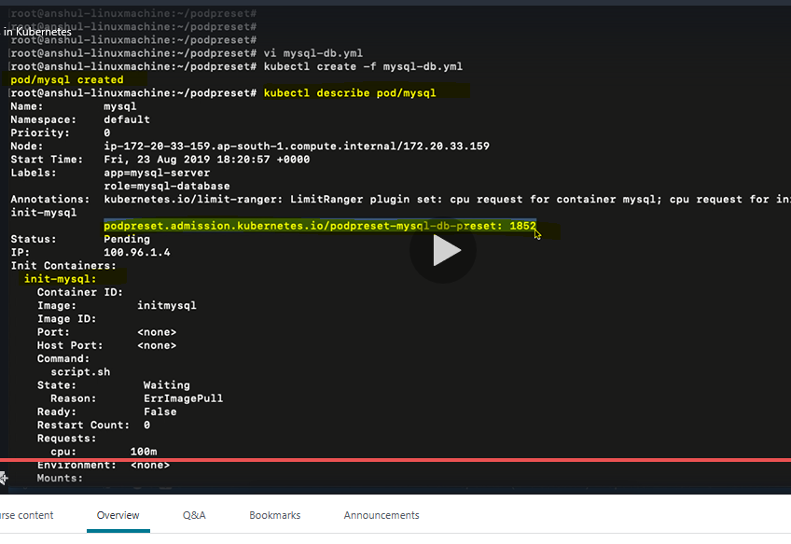

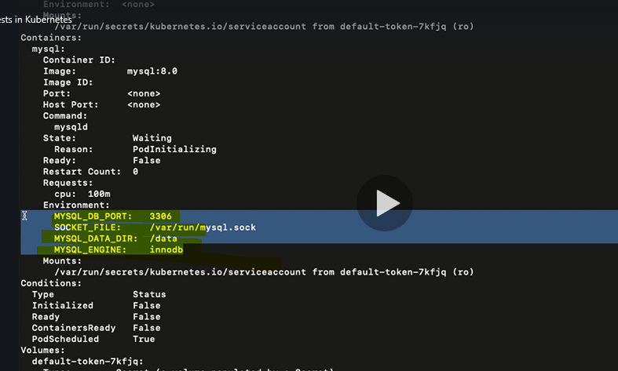

**If we create a new pod then the same presets are applied.**

**To do that copy the mysql db file and rename it to a diff name**

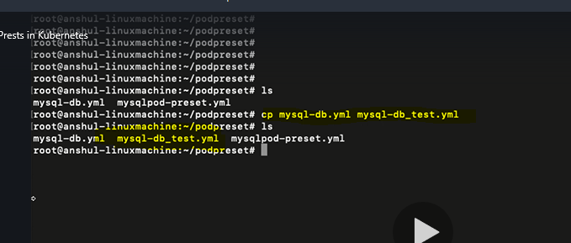

**Edit the new file by removing the initontainers, changing the name of the pod and retaining the name of the label (role)**

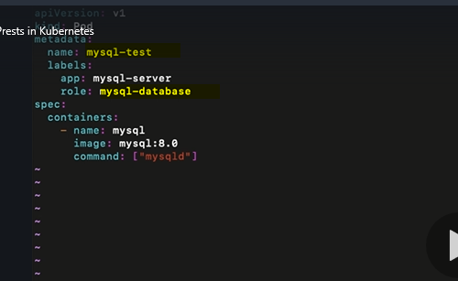

**Create the pod with the above changes**

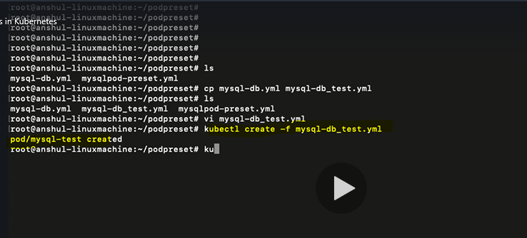

**Describe the new pod**

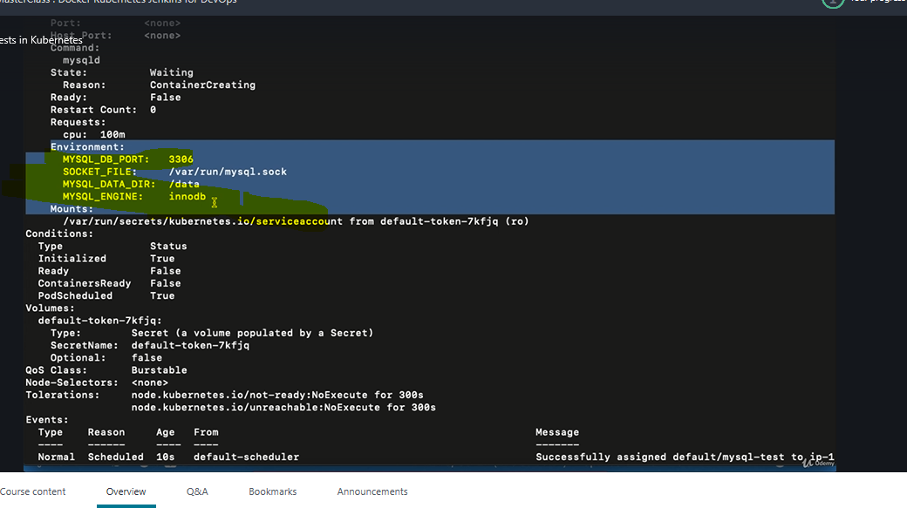

**The same presets are applied to the new pod as well.**

**Topic-2: Stateful sets in Kubernetes**

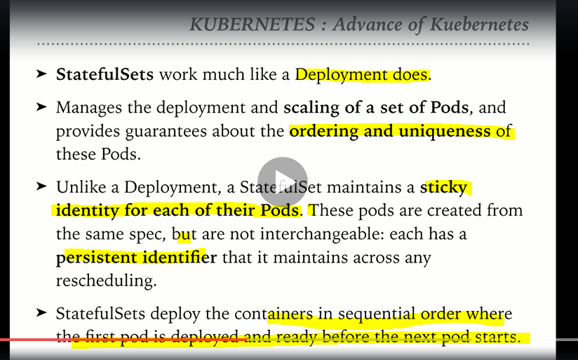

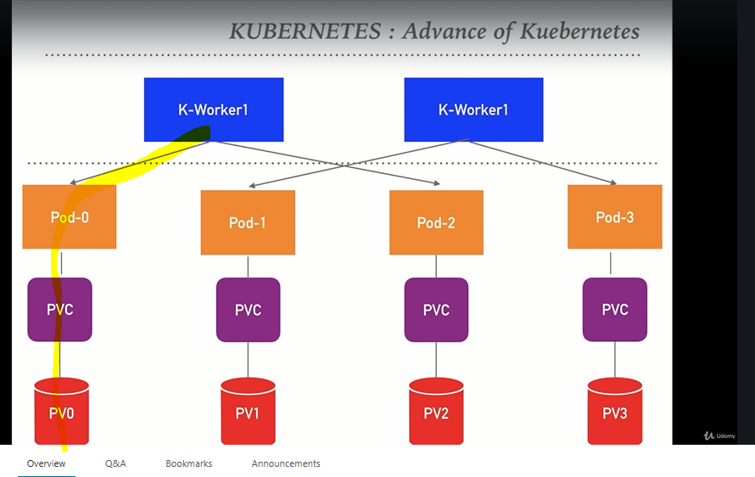

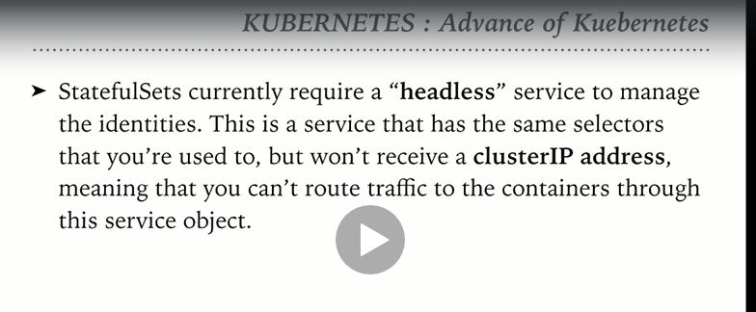

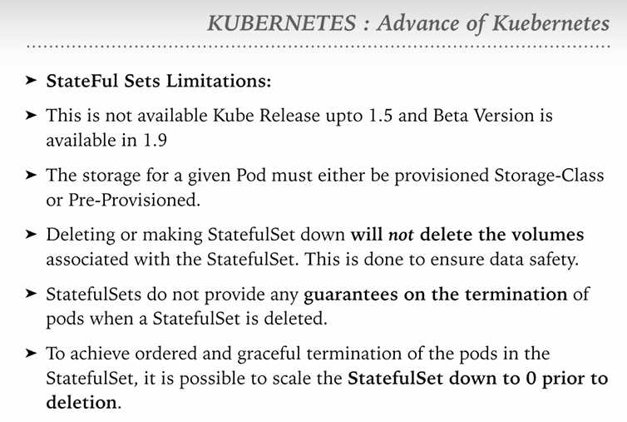

**Topic-4: Casandra with stateful set**

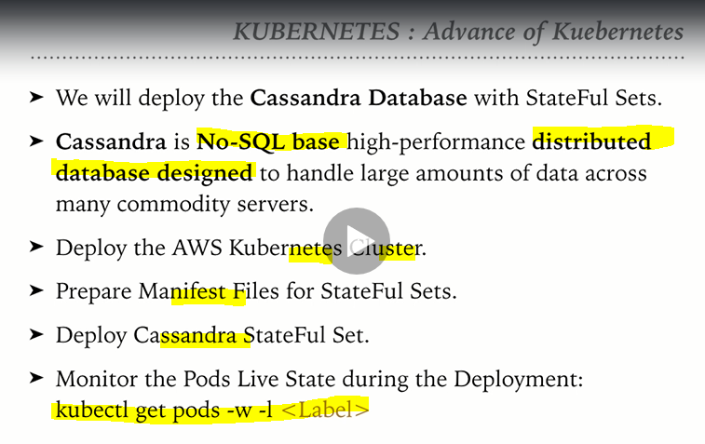

**Create a Kubernetes cluster on AWS using t2.small**

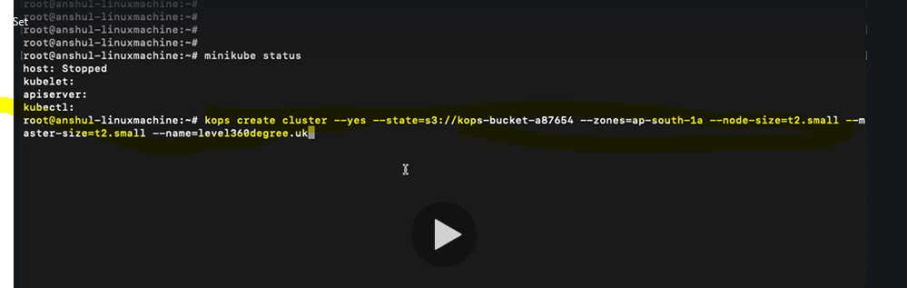

**Create a Casandra-pv.yml manifest file**

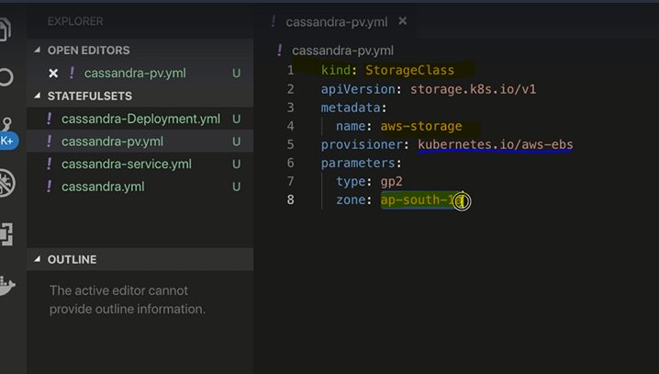

**Create a service manifest file**

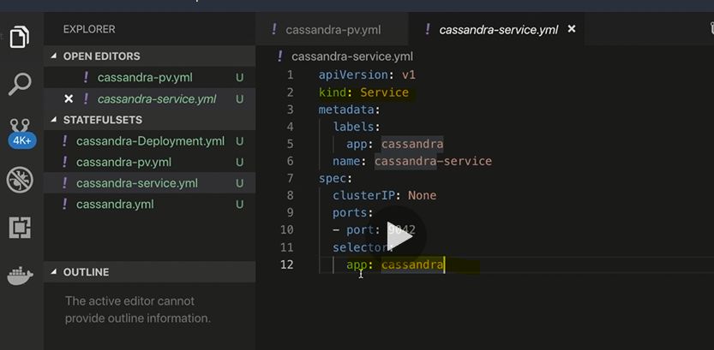

**Note: To separate between the manifest data we can use ---**

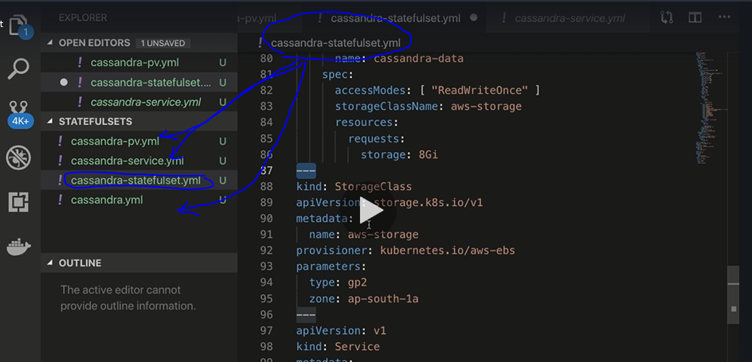

**All there manifest’s contents are combined together in a single manifest file using --- for demarcation.**

**Note: There is no order which is to be followed while combining more than 1 manifest contents. Kubernetes will automatically take care of which one to execute first**

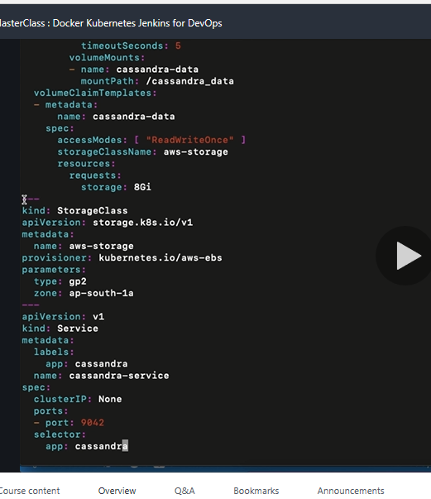

**Validate the state of the Kubernetes cluster**

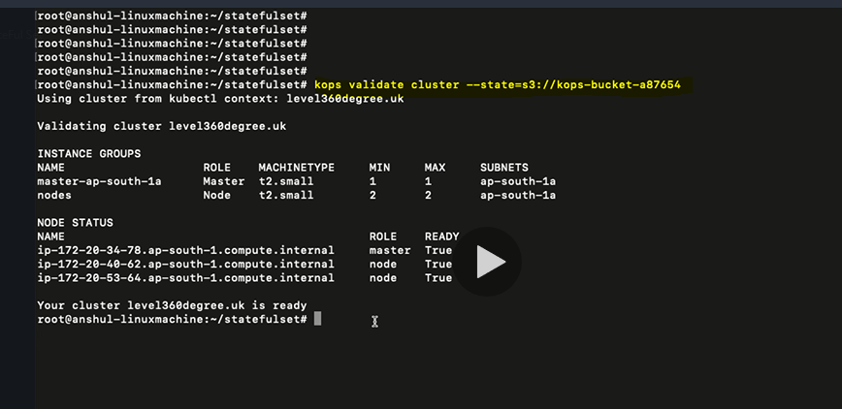

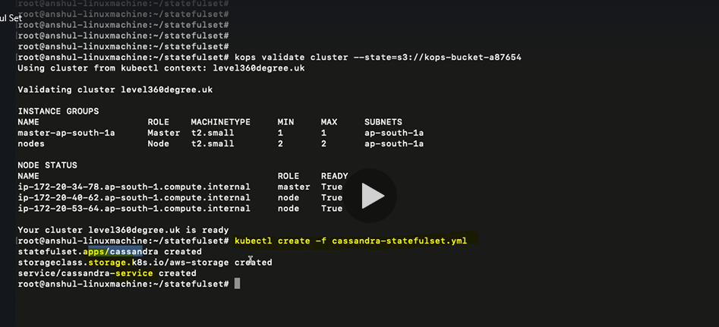

**Note the order in which the services are created. Apps>storage>service.**

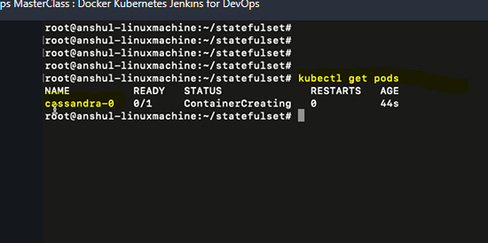

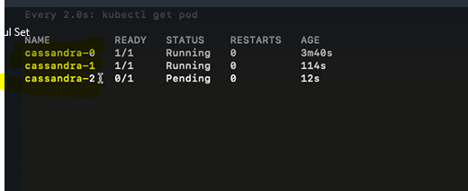

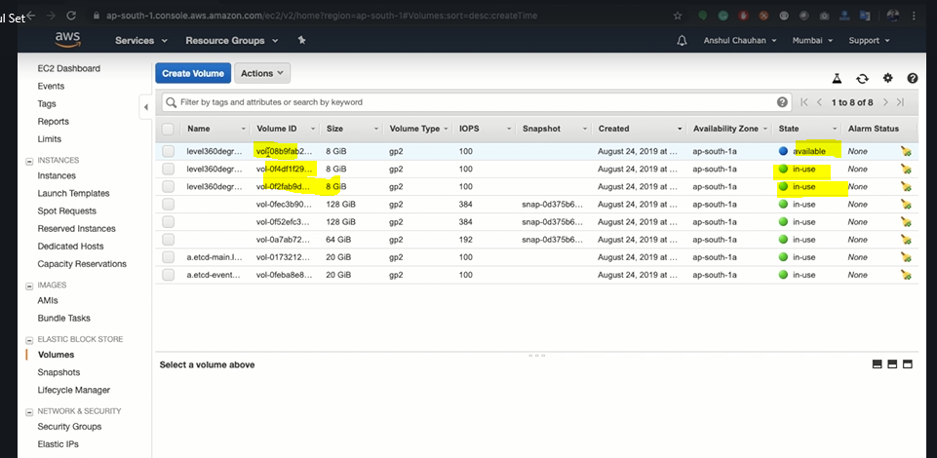

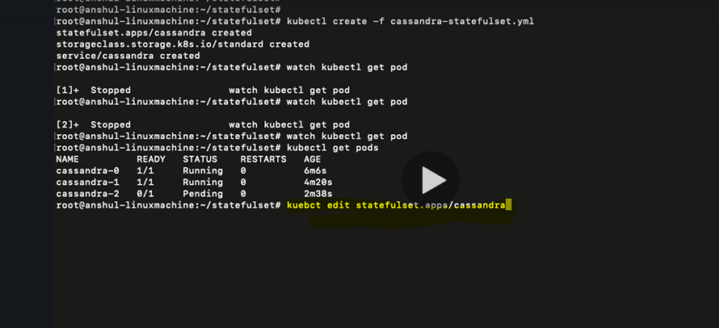

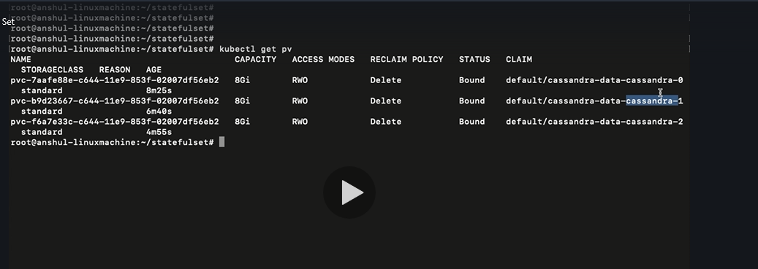

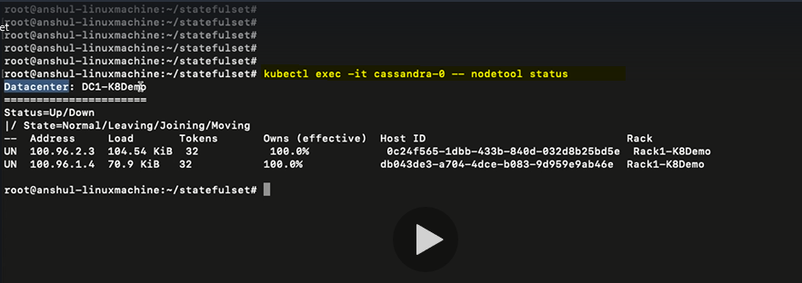

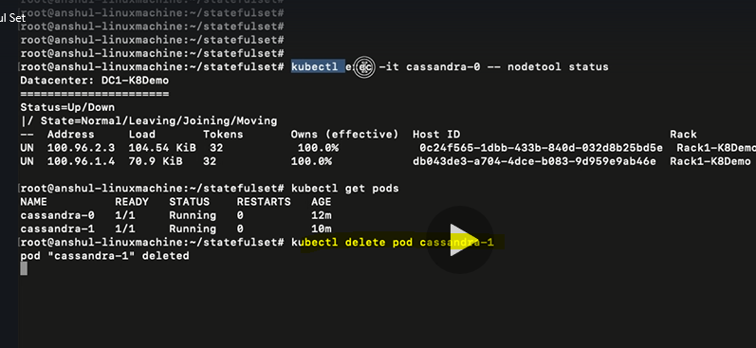

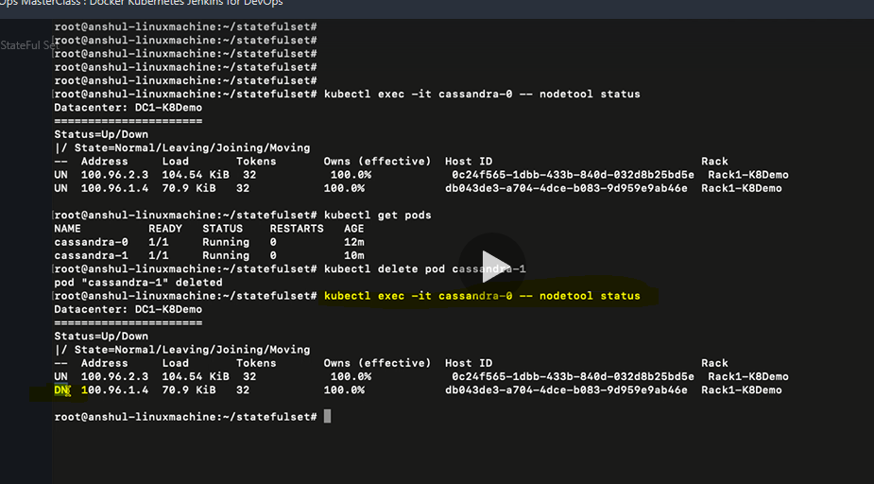

**In the highlighted status DN: D means Down and N means normal**

**Notice that the the new pod is created with the same name**

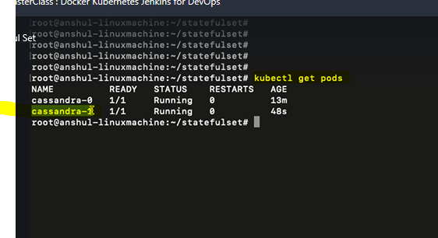

**Edit the manifest and reduce the replica from 2 to 0**

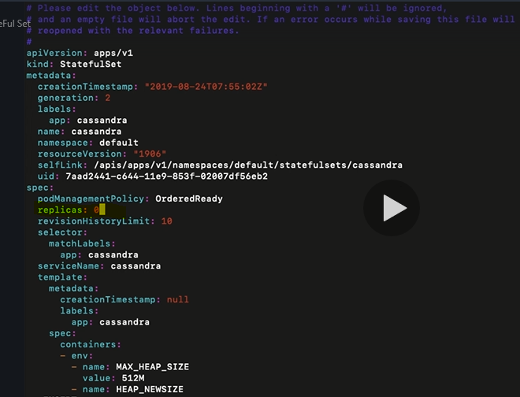

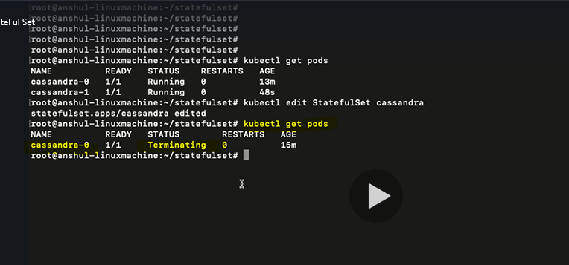

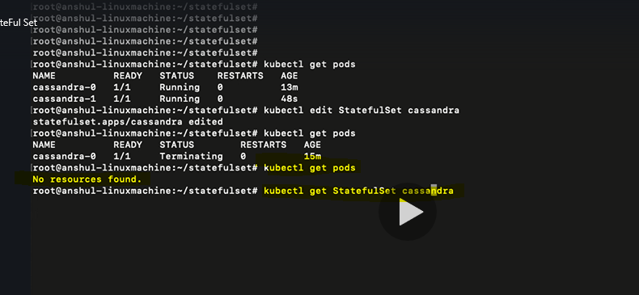

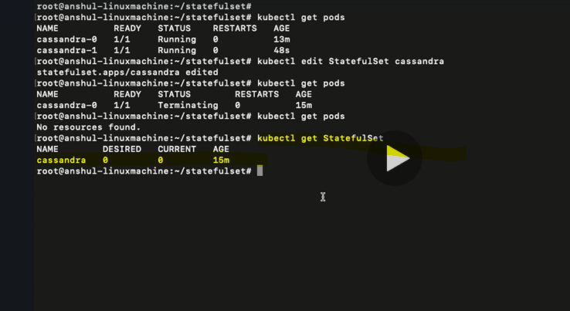

**But the volumes are not deleted but available.**

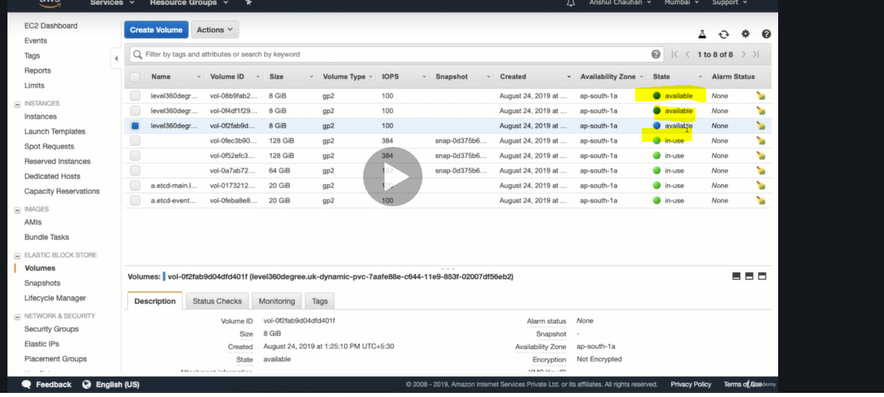

**If you want to delete the volumes then we need to explicitly remove the volumes**

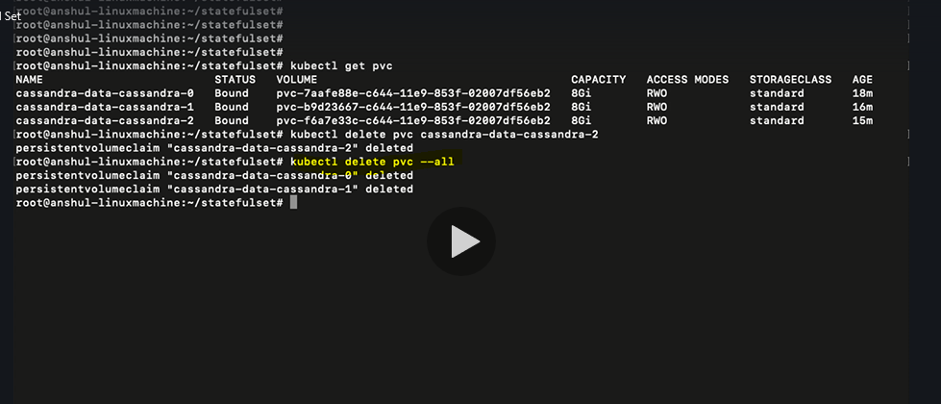

**Topic-3: Daemon set**

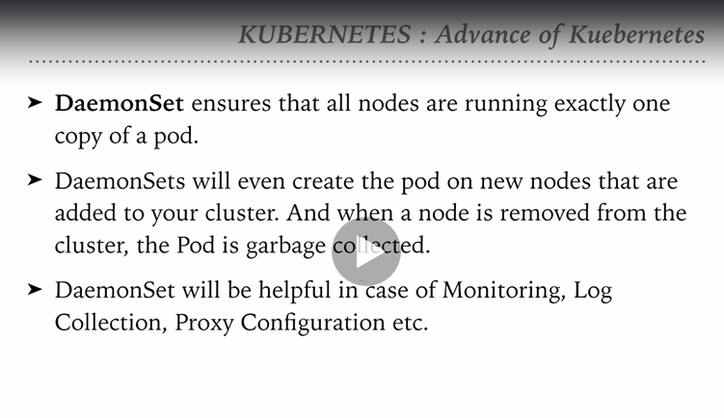

**Verify if the cluster is running:**

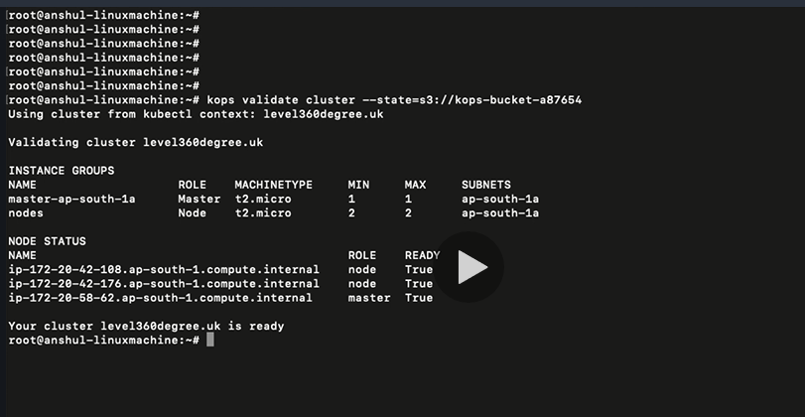

**Create a Daemon set manifest file**

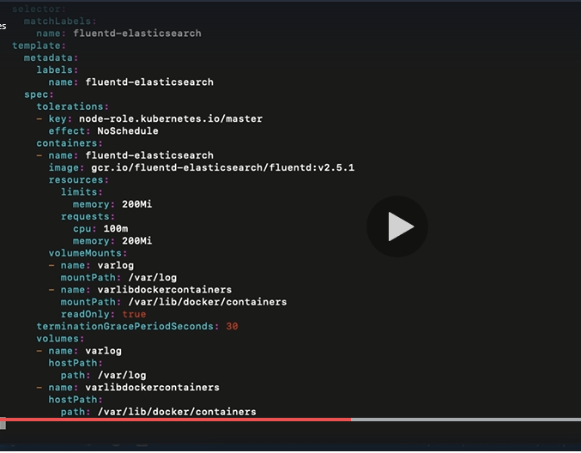

**Verify the number of nodes executing in Kubernetes cluster**

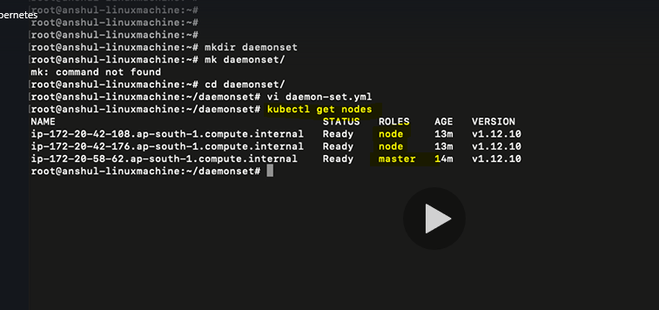

**Create the daemon set and verify the number of Pods**

**There are 3 different pods created for each node in the cluster.**

**Note:** We have not mentioned number of replicas in the manifest file.

